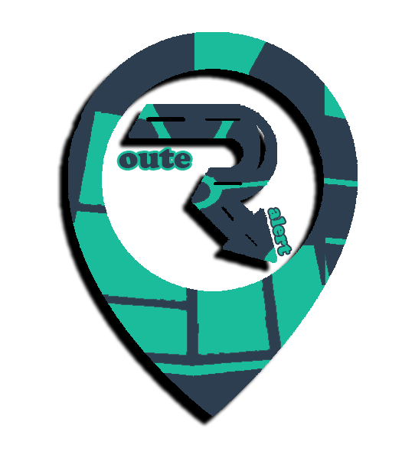

User Manual

ROUTE ALERT

|  |
| --- |
| **1-How to Open Route Alert** |

**1-Install RouteAlert App.**

**2-Click on RouteAlert icon to run App.**



|  |
| --- |
| **1-How to Register on Route Alert** |

**3-Wellcome to Route Alert**

**­­­**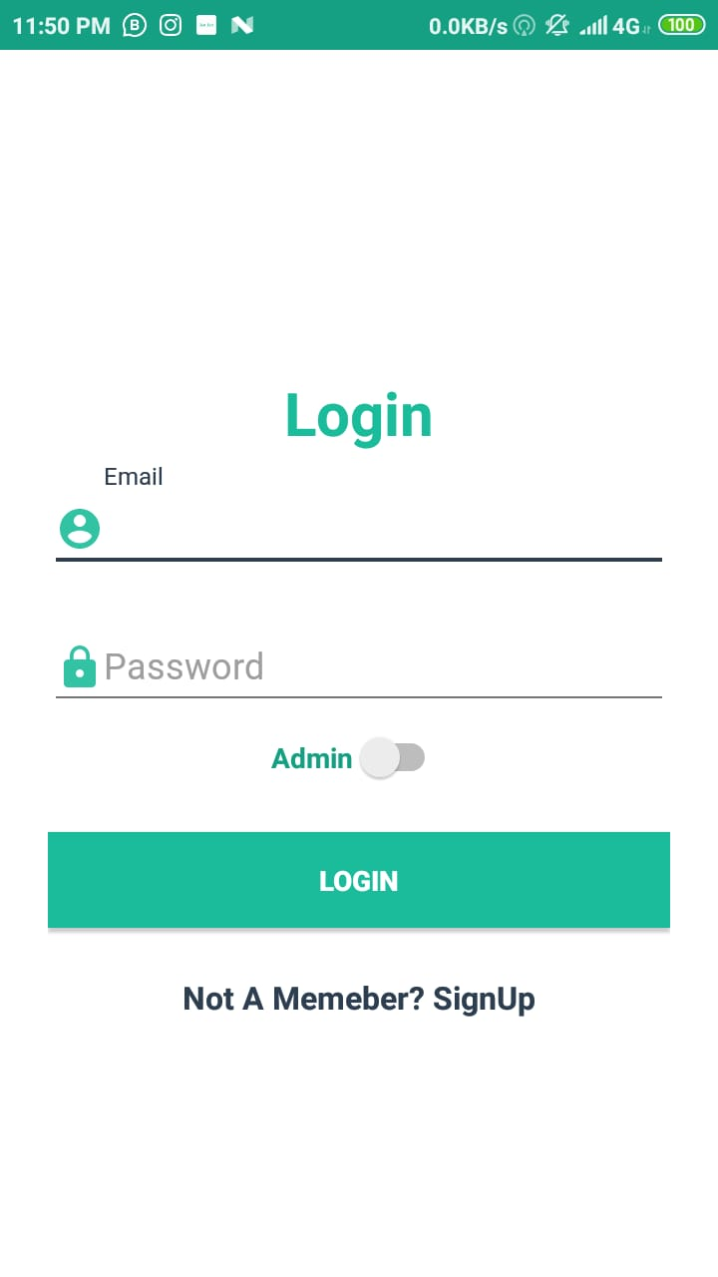

**1-Tap on Don’t have An Account Click here**



**WellCome RouteAlert :**

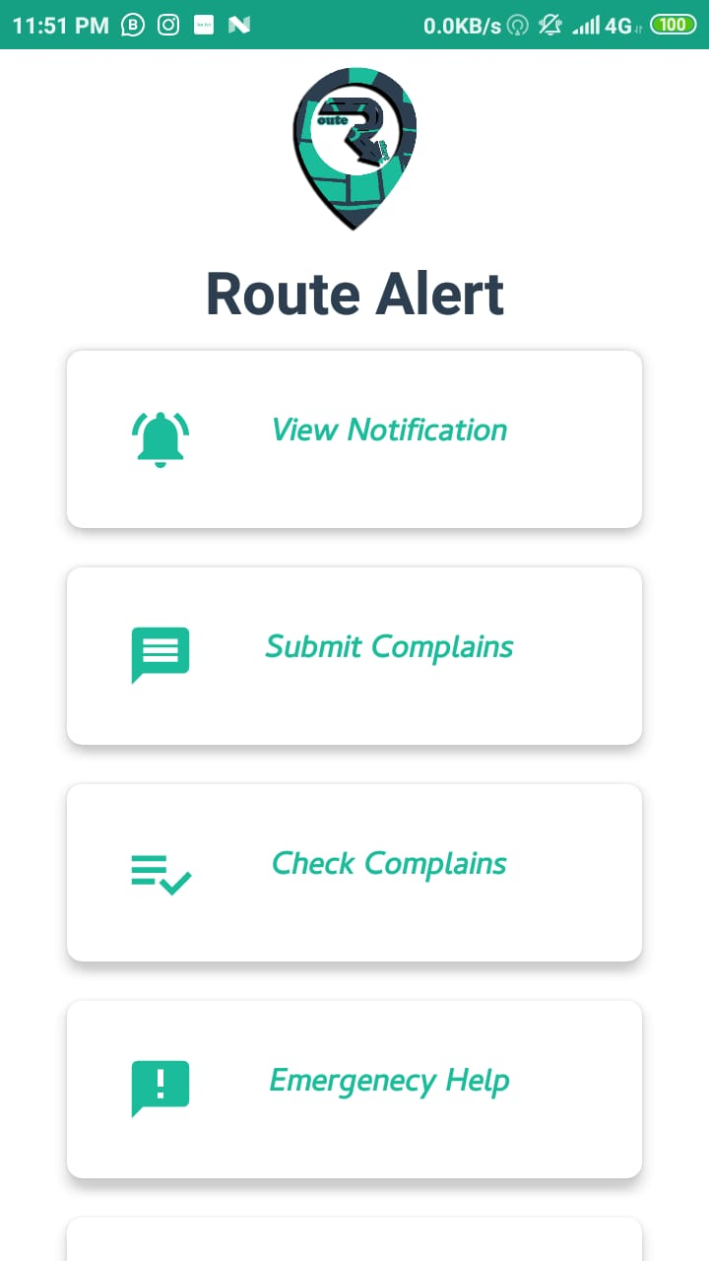

**2-Fill all requirement which need you to register**

**.**

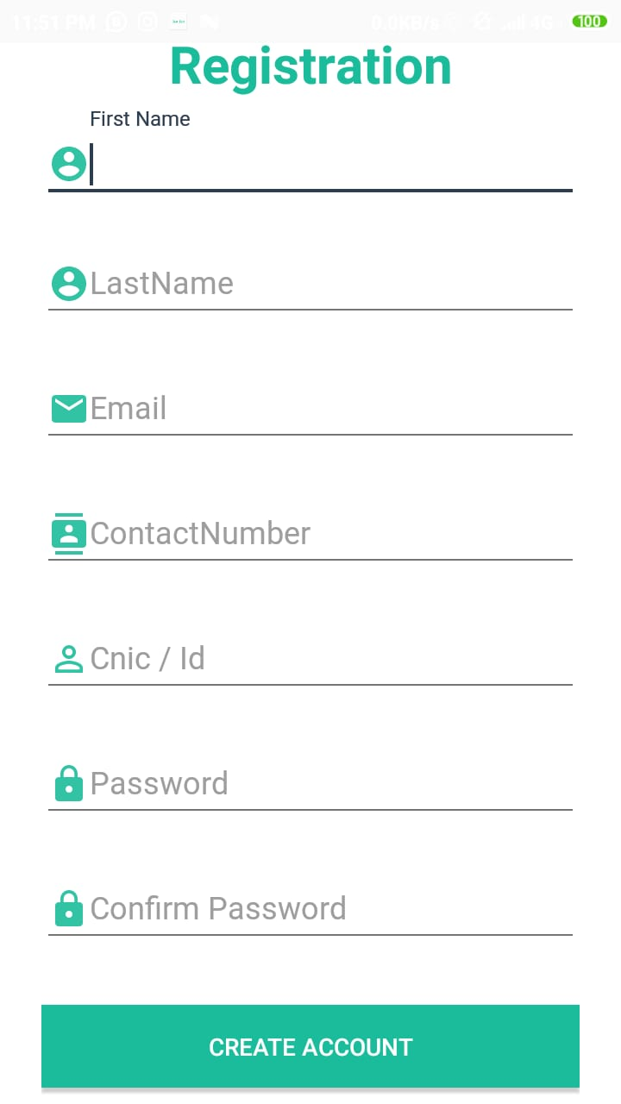

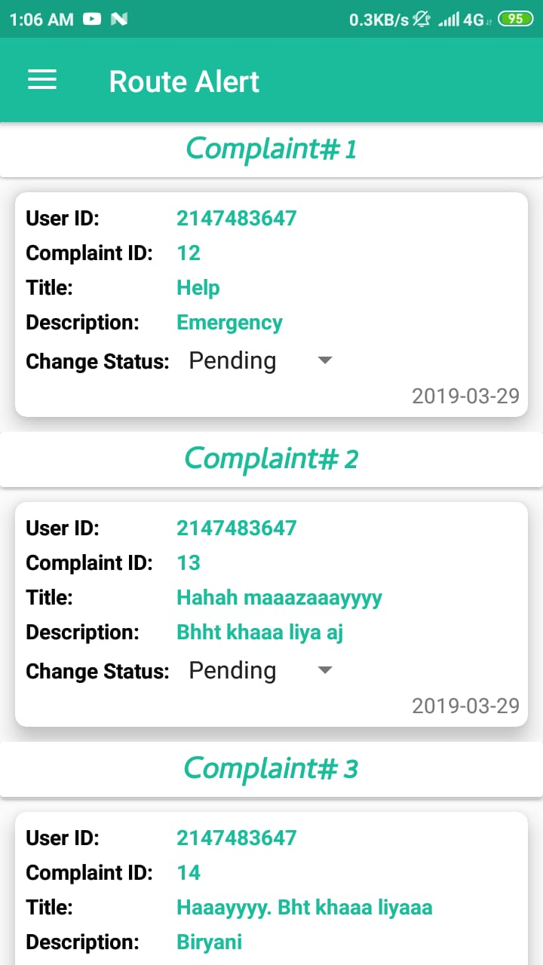

**Complaint:**

**3-After fill all requirement tap on signup button for successfully registered.**



**4-when you tap signup for registration request sent to the admin and admin**

**Approve your request her admin approve your request then your account has**

**Been create successfully.**

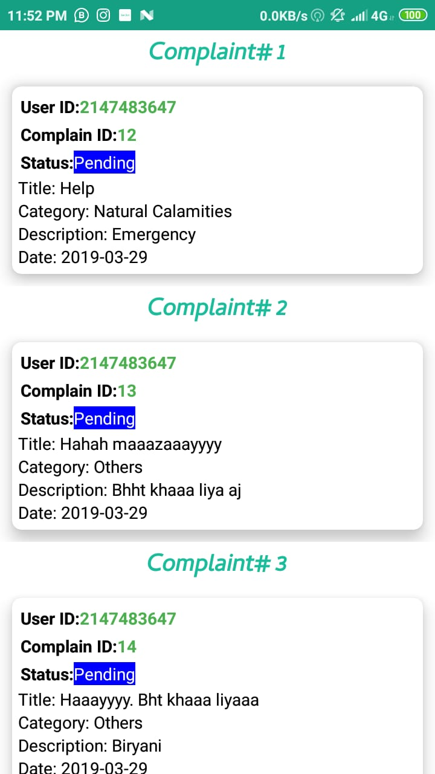

**Emergency Help :**

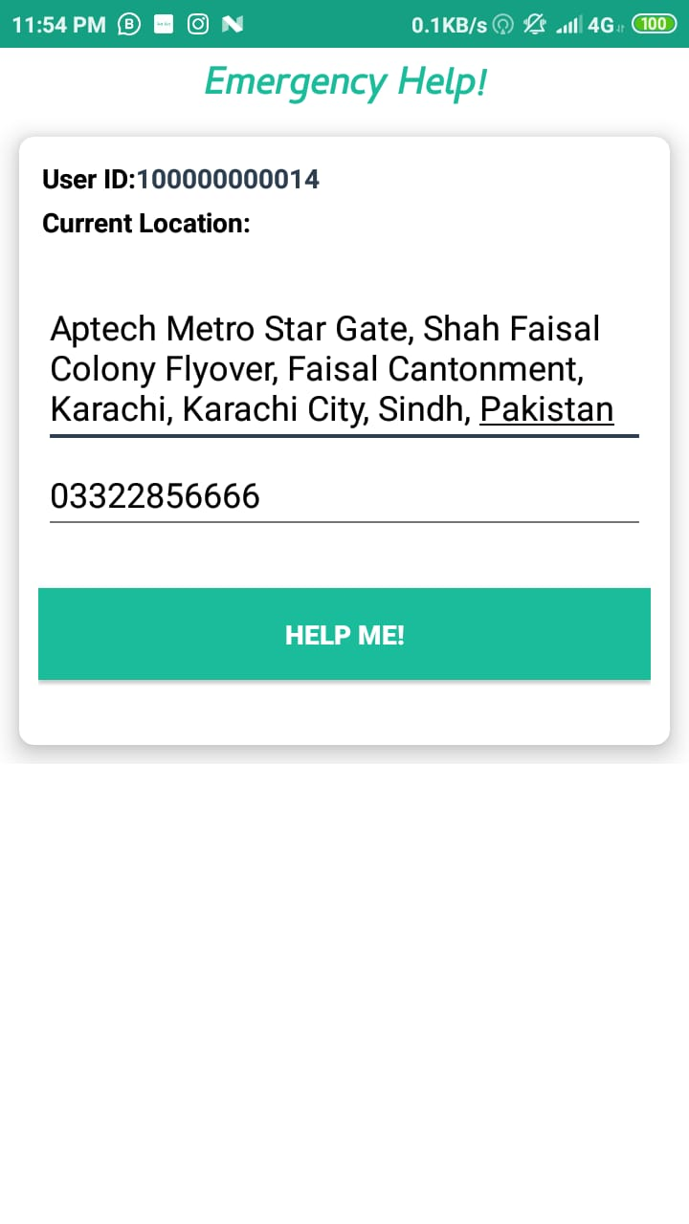

**FeedBack:**



